#7
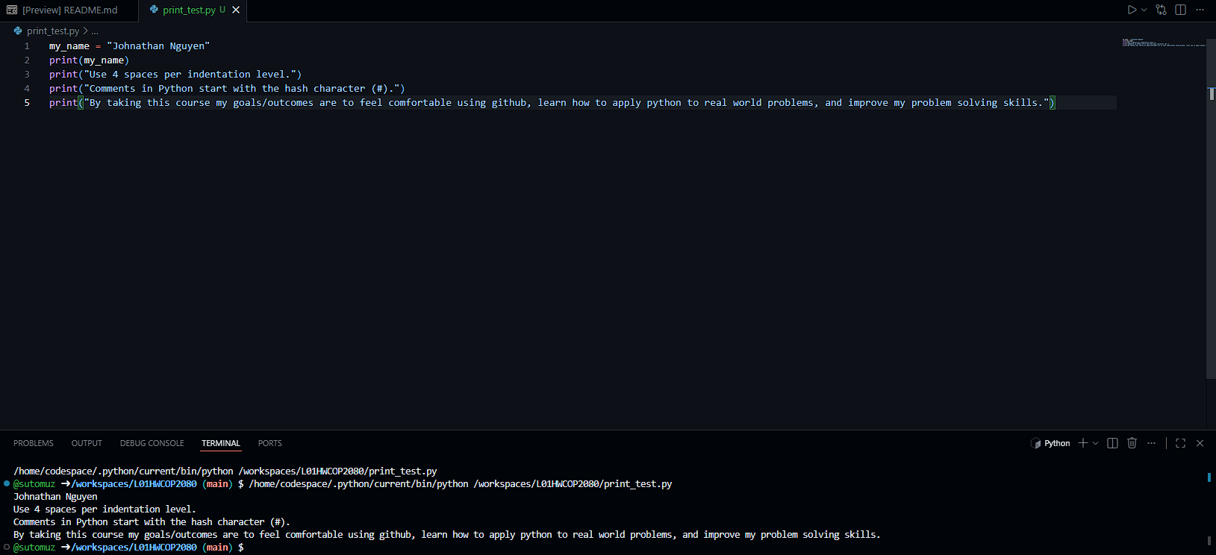
#9
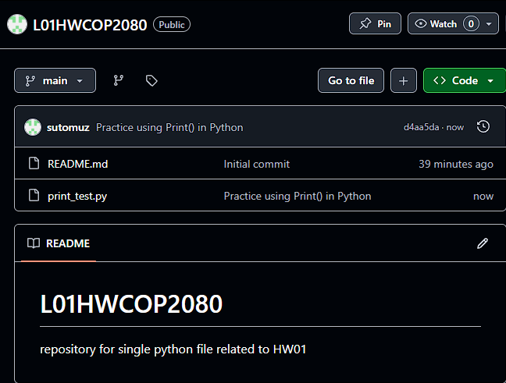
#10 https://github.com/sutomuz/L01HWCOP2080.git

